FLIGHT ACTIVITY

*--the most freq destination airports*

SELECT * FROM (

SELECT FLIGHT.ARRIVAL_AIRPORT, COUNT(FLIGHT.ARRIVAL_AIRPORT ) AS COUNT

FROM FLIGHT,FLIGHT_ACTIVITY

WHERE FLIGHT_ID = FLIGHT.ID

GROUP BY FLIGHT.ARRIVAL_AIRPORT

ORDER BY COUNT DESC)

WHERE ROWNUM <= 10

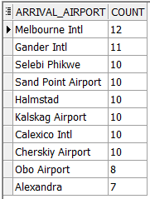

*--The proportion of every fare basis the flyers take*

SELECT FARE_BASIS.CODE , COUNT(FARE_BASIS.CODE )/(SELECT COUNT(*) FROM FLIGHT_ACTIVITY) * 100 ||'%' AS PERC

FROM FARE_BASIS,FLIGHT_ACTIVITY

WHERE FARE_BASIS_ID = FARE_BASIS.ID

GROUP BY FARE_BASIS.CODE

ORDER BY PERC DESC;

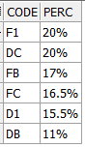

*--how often they upgrade*

SELECT PASSENGER_ID,COUNT(*)

FROM (

SELECT DISTINCT PASSENGER_ID,FARE_BASIS.CODE , COUNT(FARE_BASIS.CODE) OVER(PARTITION BY FLIGHT_ACTIVITY.PASSENGER_ID, FLIGHT_ACTIVITY.FARE_BASIS_ID) COUNT_

FROM FLIGHT_ACTIVITY,FARE_BASIS

WHERE FLIGHT_ACTIVITY.FARE_BASIS_ID = FARE_BASIS.ID

)

GROUP BY PASSENGER_ID

ORDER BY count(*) desc;

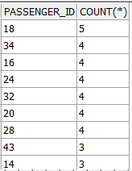

*--Calculate average*

SELECT AVG(COUNT) FROM

(SELECT PASSENGER_ID,COUNT(*) AS COUNT

FROM (

SELECT DISTINCT PASSENGER_ID,FARE_BASIS.CODE , COUNT(FARE_BASIS.CODE) OVER(PARTITION BY FLIGHT_ACTIVITY.PASSENGER_ID, FLIGHT_ACTIVITY.FARE_BASIS_ID) COUNT_

FROM FLIGHT_ACTIVITY,FARE_BASIS

WHERE FLIGHT_ACTIVITY.FARE_BASIS_ID = FARE_BASIS.ID

)

GROUP BY PASSENGER_ID)



*--how much miles they earn*

SELECT PASSENGER_ID,SUM(DISTANCE_IN_MILES) AS EARN

FROM FLIGHT_ACTIVITY

GROUP BY PASSENGER_ID;

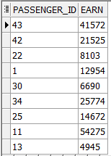

*--the proportion of promotion fare vs. full fare*

SELECT

(SELECT COUNT(*) FROM FLIGHT_ACTIVITY,FARE_BASIS WHERE FARE_BASIS_ID = ID AND CODE IN ('D1','DB','DC'))

/(SELECT COUNT(*) FROM FLIGHT_ACTIVITY) * 100||'%' AS DISCOUNT_FARE

,(SELECT COUNT(*) FROM FLIGHT_ACTIVITY,FARE_BASIS WHERE FARE_BASIS_ID = ID AND CODE IN ('F1','FB','FC'))/(SELECT COUNT(*) FROM FLIGHT_ACTIVITY) * 100||'%' AS FULL_FARE

FROM DUAL



*--proportion of membership status for passengers*

SELECT STATUS,COUNT(STATUS)/ (SELECT COUNT(*) FROM FREQ_PASSENGER) *100||'%'

FROM FREQ_PASSENGER

GROUP BY STATUS

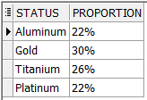

*--average number of nights they stay in hotels*

UPDATE OVERNIGHT_STAYS SET NUMBER_OF_NIGHTS = DATE_OF_DEPARTURE_KEY - DATE_OF_ARRIVAL_KEY

SELECT AVG(NUMBER_OF_NIGHTS) FROM OVERNIGHT_STAYS



Financial analysis

*--profit per year*

SELECT YEAR,SUM(PAYMENT_AMOUNT) AS PROFIT

FROM RESERVATION,DATE_TABLE

WHERE DATE_ID=KEY

GROUP BY YEAR

ORDER BY YEAR DESC

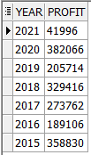

*--profit per quarter for every year*

SELECT YEAR,QUARTER,SUM(PAYMENT_AMOUNT) AS PROFIT

FROM RESERVATION,DATE_TABLE

WHERE DATE_ID=KEY

GROUP BY YEAR,QUARTER

ORDER BY YEAR,QUARTER DESC

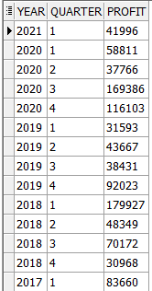

*--profit per every month for every year*

SELECT YEAR,QUARTER,MONTH_NAME,SUM(PAYMENT_AMOUNT) AS PROFIT

FROM RESERVATION,DATE_TABLE

WHERE DATE_ID=KEY

GROUP BY YEAR,QUARTER,MONTH_NAME

ORDER BY YEAR,QUARTER,MONTH_NAME DESC

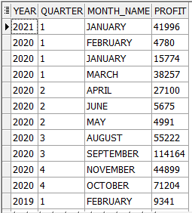

*--profit from every reservation channel*

SELECT TYPE, SUM(PAYMENT_AMOUNT) AS PROFIT

FROM RESERVATION, RESERVATION_CHANNEL

WHERE ID=RESERVATION_CHANNEL_ID

GROUP BY TYPE

ORDER BY PROFIT DESC

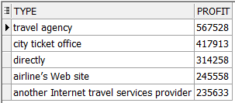

*--profit from every reservation channel for every year*

SELECT YEAR,TYPE, SUM(PAYMENT_AMOUNT) AS PROFIT

FROM RESERVATION, RESERVATION_CHANNEL ,DATE_TABLE

WHERE ID=RESERVATION_CHANNEL_ID AND DATE_ID=KEY

GROUP BY YEAR,TYPE ORDER BY YEAR

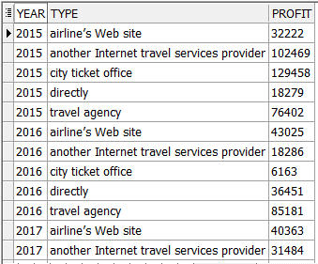

CUSTOMER CARE

*--average feedback rate before, within and after the flight*

SELECT TYPE, ROUND(AVG(FEEDBACK_RATE),2) AS AVG_FEEDBACK_RATE

FROM CUSTOMER_CARE,INTERACTION

WHERE INTERACTION_ID = INTERACTION.ID

GROUP BY TYPE

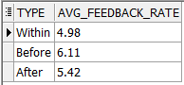

*--average problem severity before, within and after the flight*

SELECT TYPE,ROUND(AVG(PROBLEM_SEVERITY),2) AS AVG_PROBLEM_SEVERITY

FROM CUSTOMER_CARE,INTERACTION

WHERE INTERACTION_ID = INTERACTION.ID

GROUP BY TYPE

